# 

# RAF Manufacturing Test Plan

Version 1.0

Kevin Osborn

September 6, 2017

## Overview

The RAF (Ready Aim Fire) board is and Arduino shield intended for use with an Arduino Uno R3 or compatible board. It’s function is to implement an aimable foam dart shooter for software education purposes.

## Features

* 2 axis analog joystick for aiming a pan tilt mechanism
* Button (integrated in joystick) for firing or other IO purposes
* WS2812B Addressable RGB LED for feedback
* 3 servo headers (two for pan tilt and a spare) with separate 6V power supply for servos
* 2 Mosfet outputs
  + Switched VIN (preferably 9V > 1.5A) (used to drive gas solenoid valve for firing foam dart)
  + Servo VCC (6V) provided by onboard regulator (used to drive air pump)
* Temperature sensor (for analog input tutorials) - NTC thermistor wired as a voltage divider
* Light sensor (for gesture firing and analog input tutorials) - CDS LDR wired as a voltage divider
* Expansion connectors for additional WS2812B strips, and i2c sensors

# Functions to be tested

* 1. Joystick x and y reading
  2. Button Activation
  3. WS2812B function
  4. 6 V power supply
  5. Light sensor function
  6. Temp Sensor function
  7. 6V Mosfet output
  8. VIN Mosfet output

## Method of test

* 1. Test Equipment  
     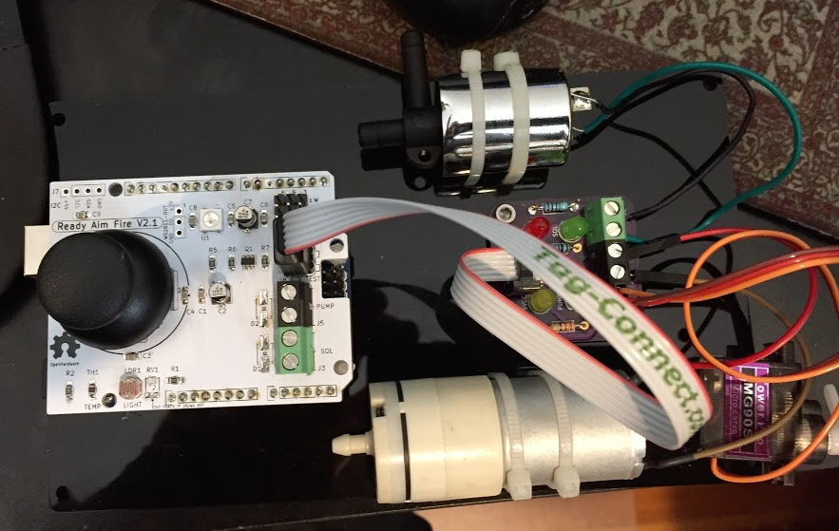
     1. Arduino loaded with test software
     2. Auxiliary analog power test board connected by ribbon cable to 6 pin test connector.
  2. Test Setup
     1. Connect the RAF shield to an Arduino Uno loaded with test software
     2. Connect Auxiliary power test board
     3. Apply VIN power
  3. Test Steps
     1. Verify that the VIN and 6V LEDs are lit on the Aux. board.  
        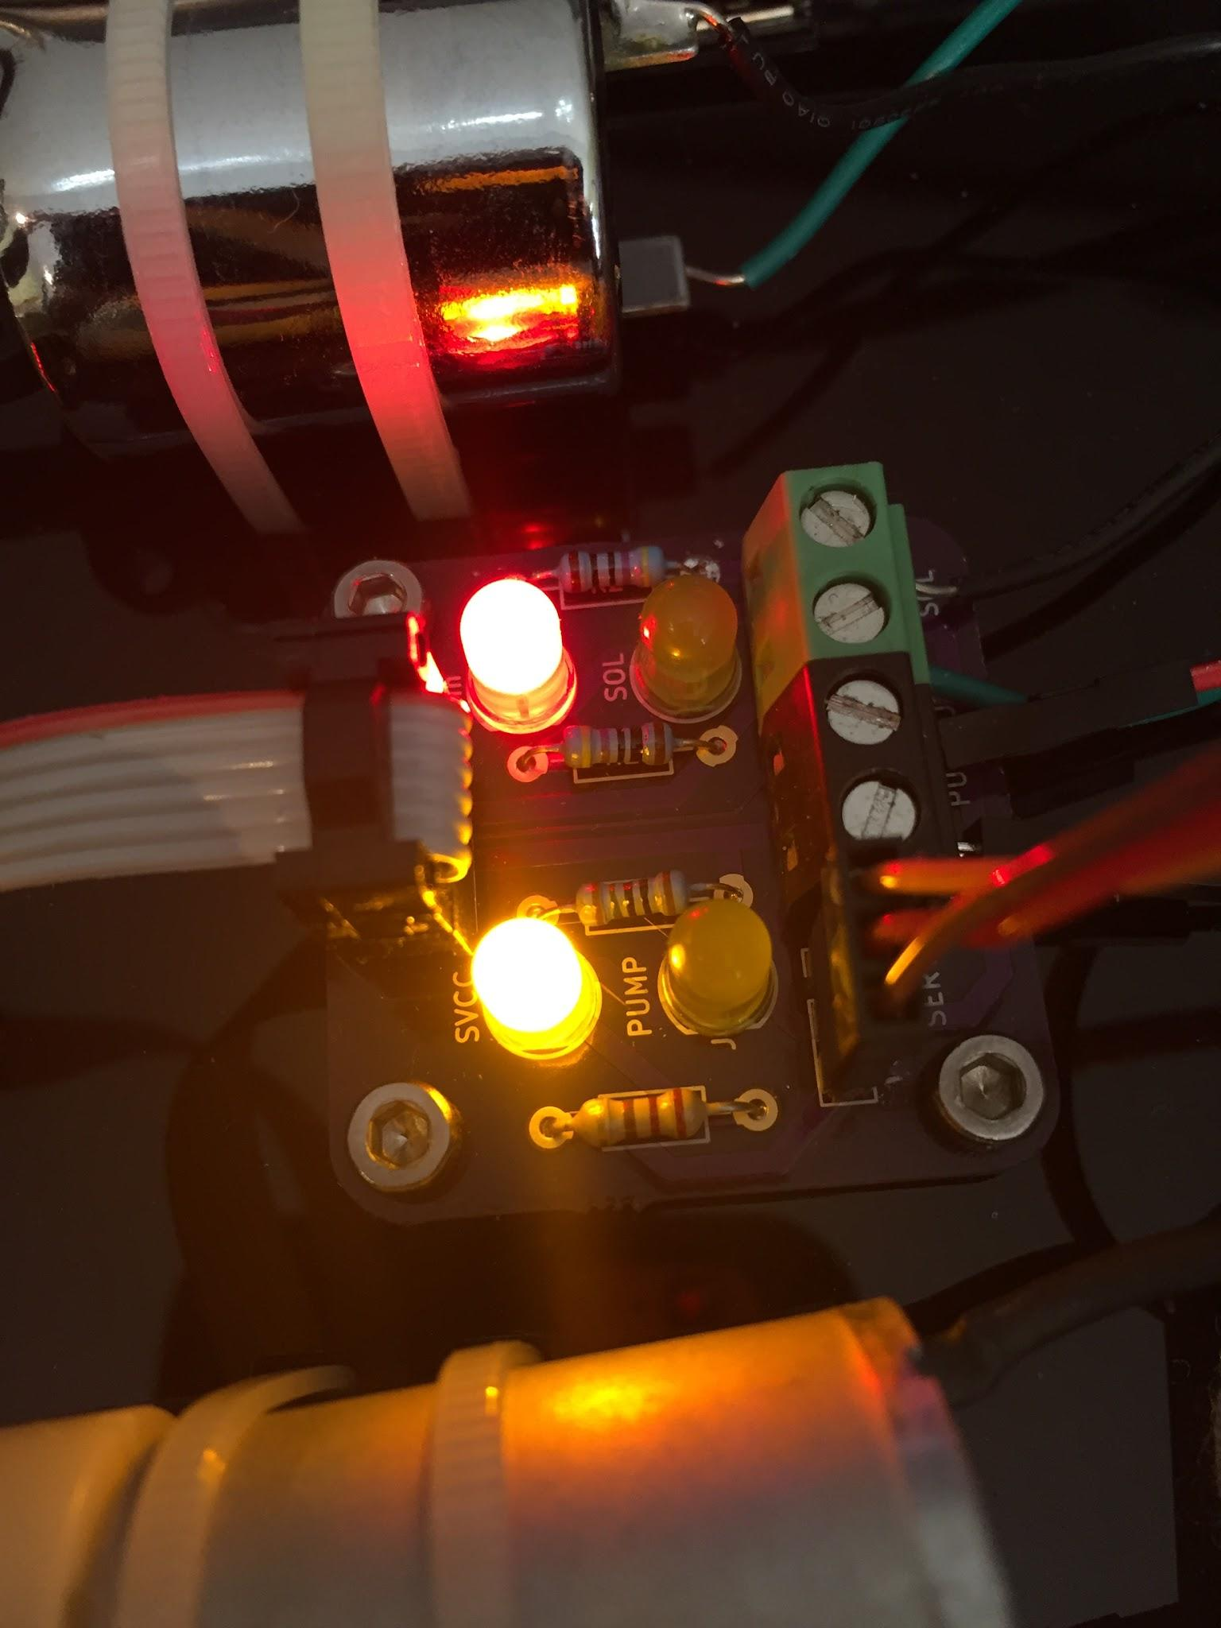
        1. LED-VIN OFF means short somewhere either at 6V LDO or Mosfet -- FAIL
        2. LED-6V OFF (and VIN on) means failure of 6V LDO - FAIL
        3. Both on - PASS
     2. Test 1 Verify that the WS2812B: Press the Joystick button (test number will flash blue)
        1. Not illuminated or white, bad WS2812B - FAIL
        2. Red, Green, Blue in sequence - PASS
     3. Test 2 Air pump: press joystick button (test number will flash blue)
        1. Air pump will come on for 1 sec. - PASS
        2. Weak or not on - Mosfet or LDO FAIL.
     4. Test 3 Solenoid: press joystick button (test number will flash blue)
        1. Solenoid will click 3 times - PASS
        2. If it doesn’t click, - Mosfet FAIL
     5. Test 4 Joystick test: click button (test number will flash blue)
        1. Move joystick to vertical and horizontal limits in both directions.   
           LED will light Green on PASS
        2. If it doesn’t light green, FAIL. Abort test by clicking button
     6. Test 5 Temperature sensor: click joystick button.(test number will flash blue)
        1. Touch TH1 with finger. If led turns green, PASS (detects slight rise in temp.)
        2. If it doesn’t turn green FAIL (or adjust firmware parameters) abort test by pushing button
     7. Test 6 Light sensor: push joystick button (test number will flash blue)
        1. Wave hand over light sensor, LED should turn green.
        2. If it doesn’t turn green FAIL (or adjust firmware parameters) abort test by pushing button
     8. Test 7 Servo test: press Joystick button (test number will flash blue)
        1. Servo should move - PASS
        2. No movment - LDO or arduino FAIL